**ACTIVITY 1: CREATE MAPS**

1. Open a Google Chrome web browser
2. In the browser, navigate to Google Maps (<https://www.google.com/maps>)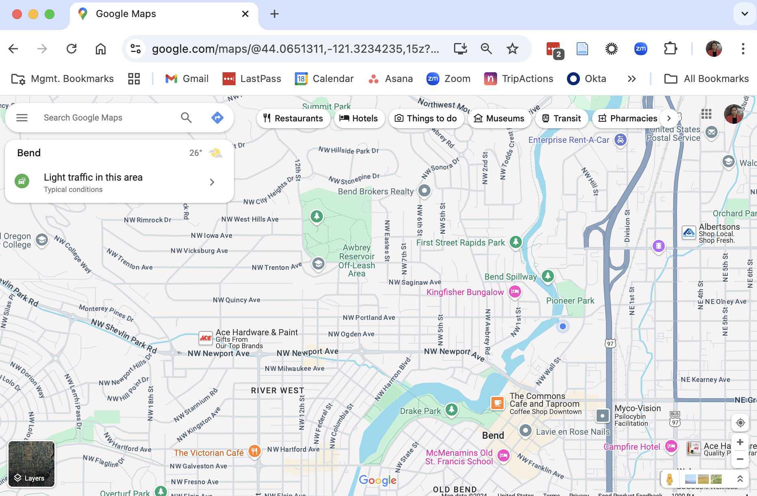
3. In the search bar, search for your favorite breakfast place in Newark, click “Save” on the left hand menu, and click “Want to Go”. This should save your breakfast place 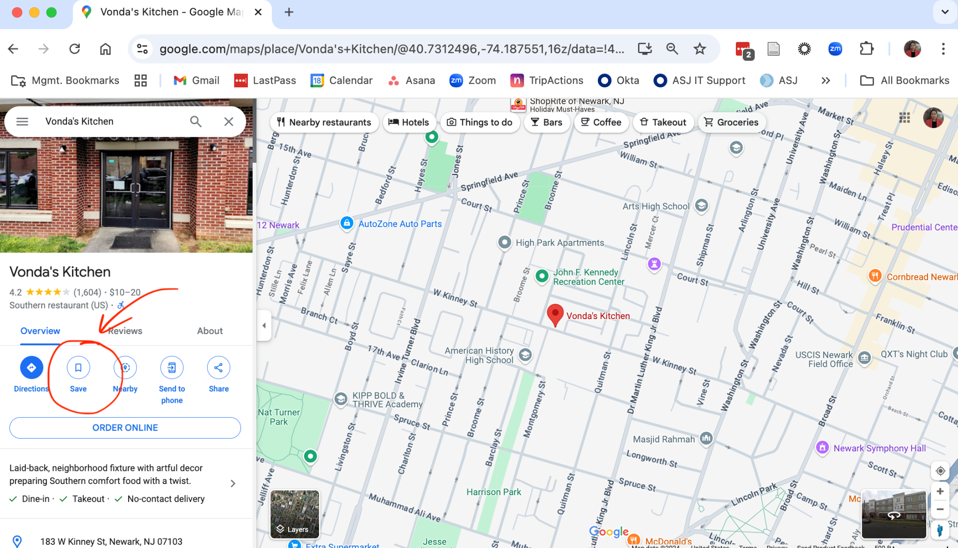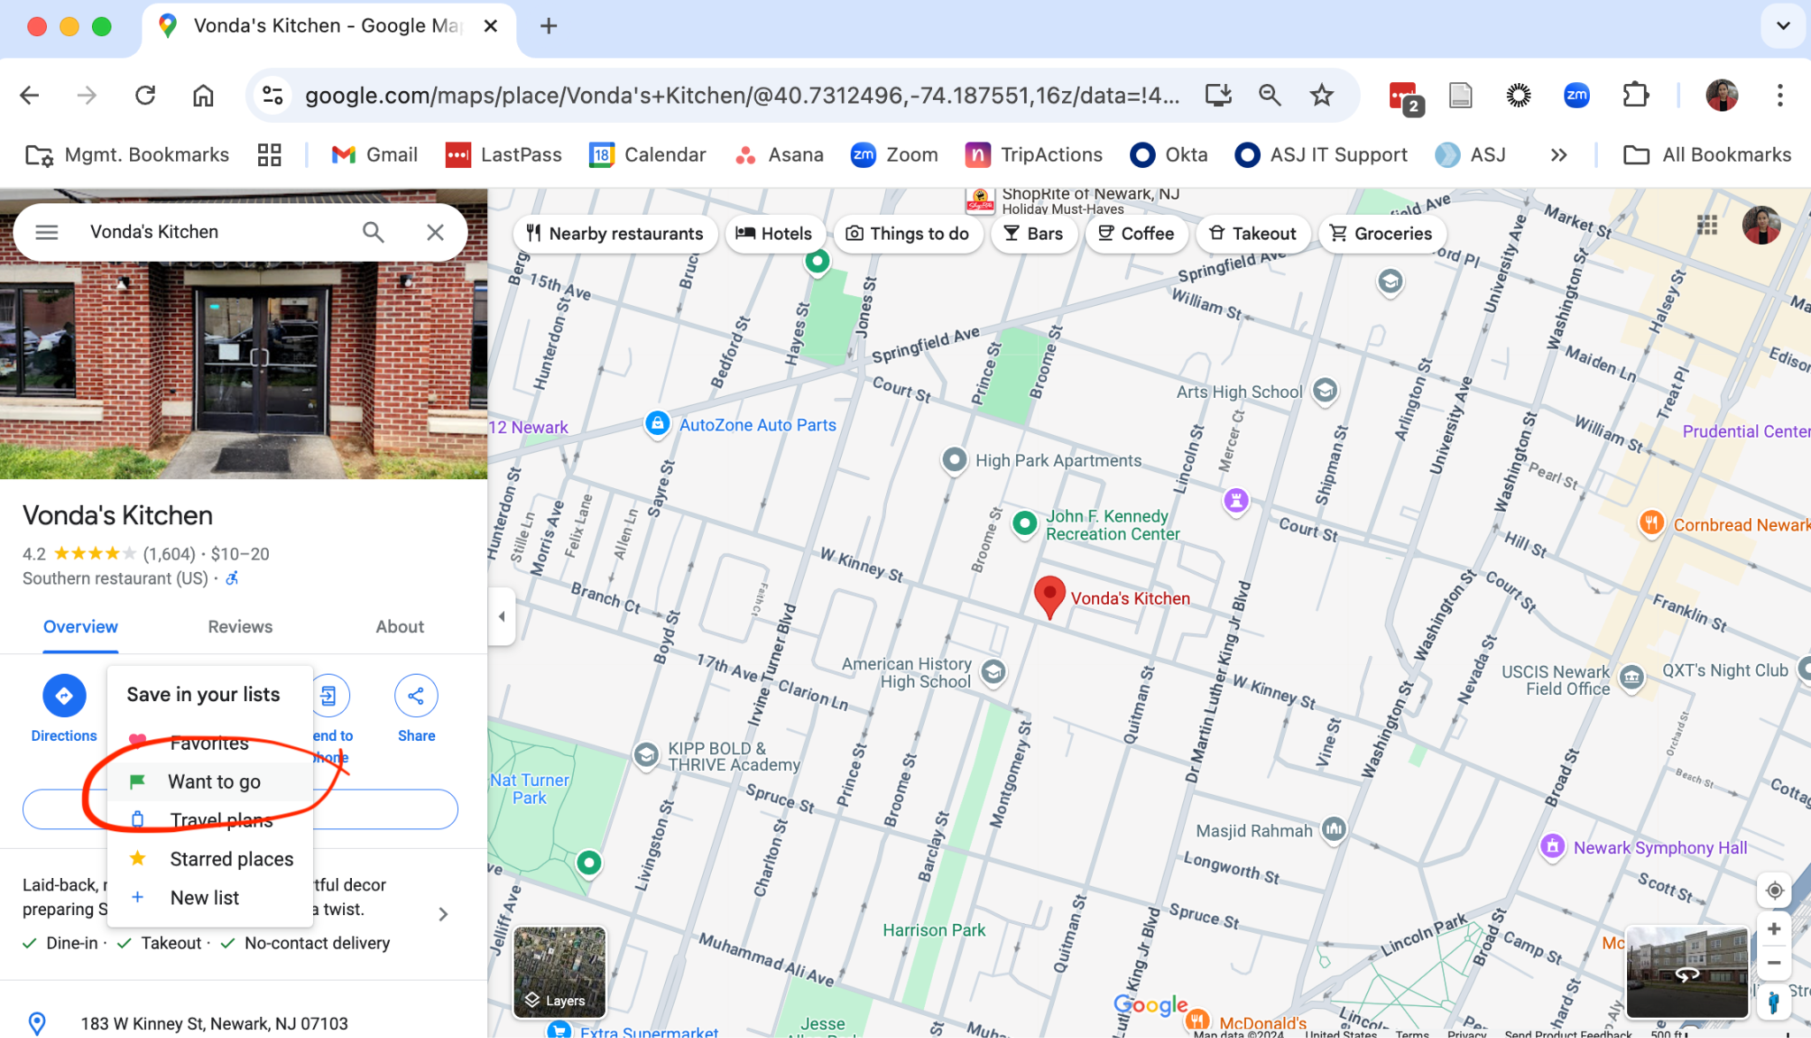
4. Repeat step 3 for your favorite Lunch spot, and favorite dinner spot
5. Go back to your menu, and click “Saved” to see your favorite spots. They should be on the map. In this example, I have saved Vonda’s Kitchen, Swahili Village, and Applebee’s as my three favorite spots in Newark. 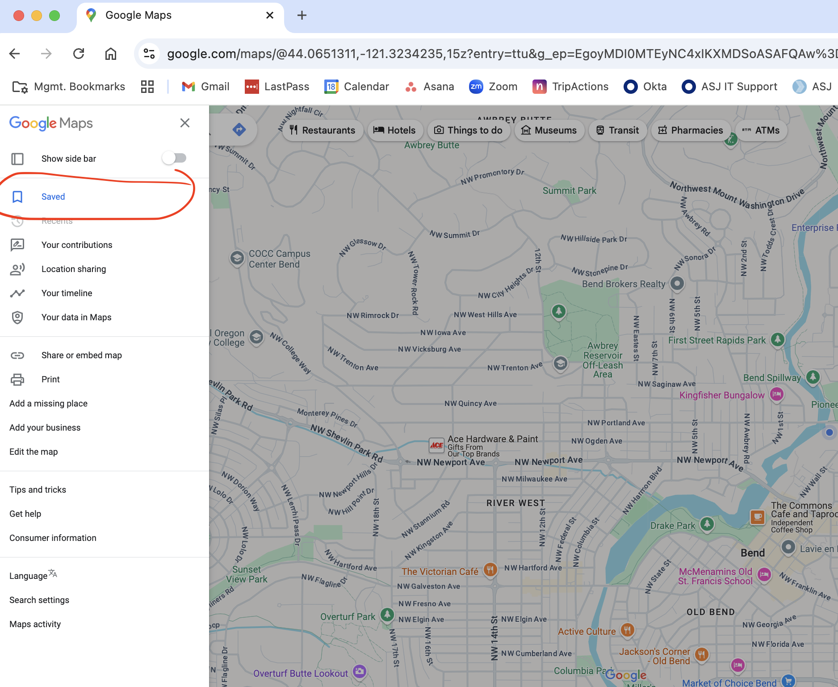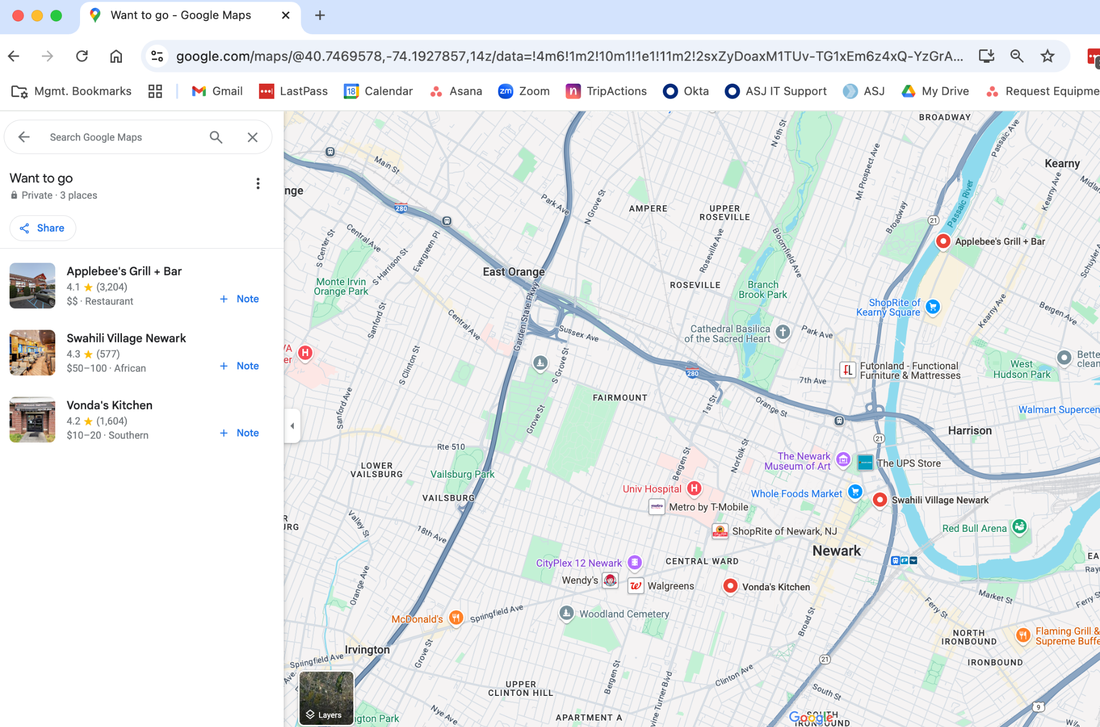
6. Navigate to your breakfast spot from the Newark International Airport
   1. Click on your favorite breakfast spot from your “Want To Go” list
   2. Click on “Directions”
   3. Type in “Newark Airport” and navigate to your breakfast place from the airport

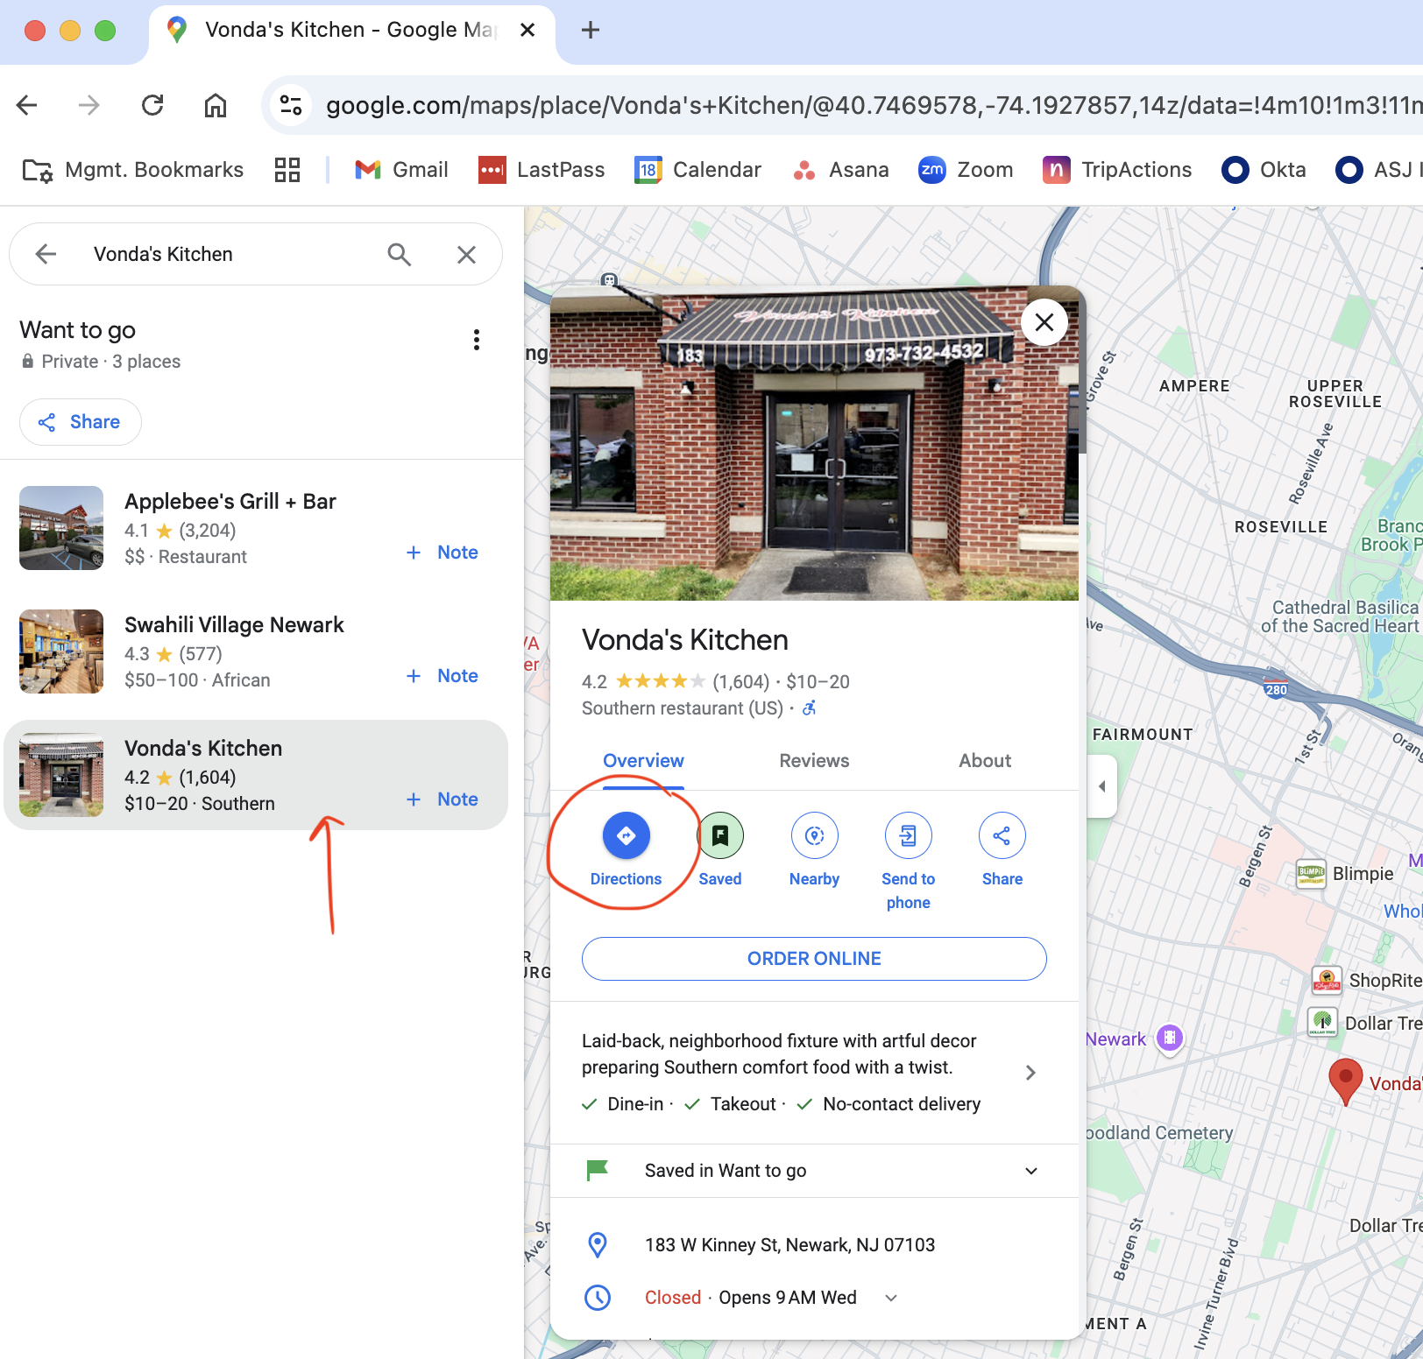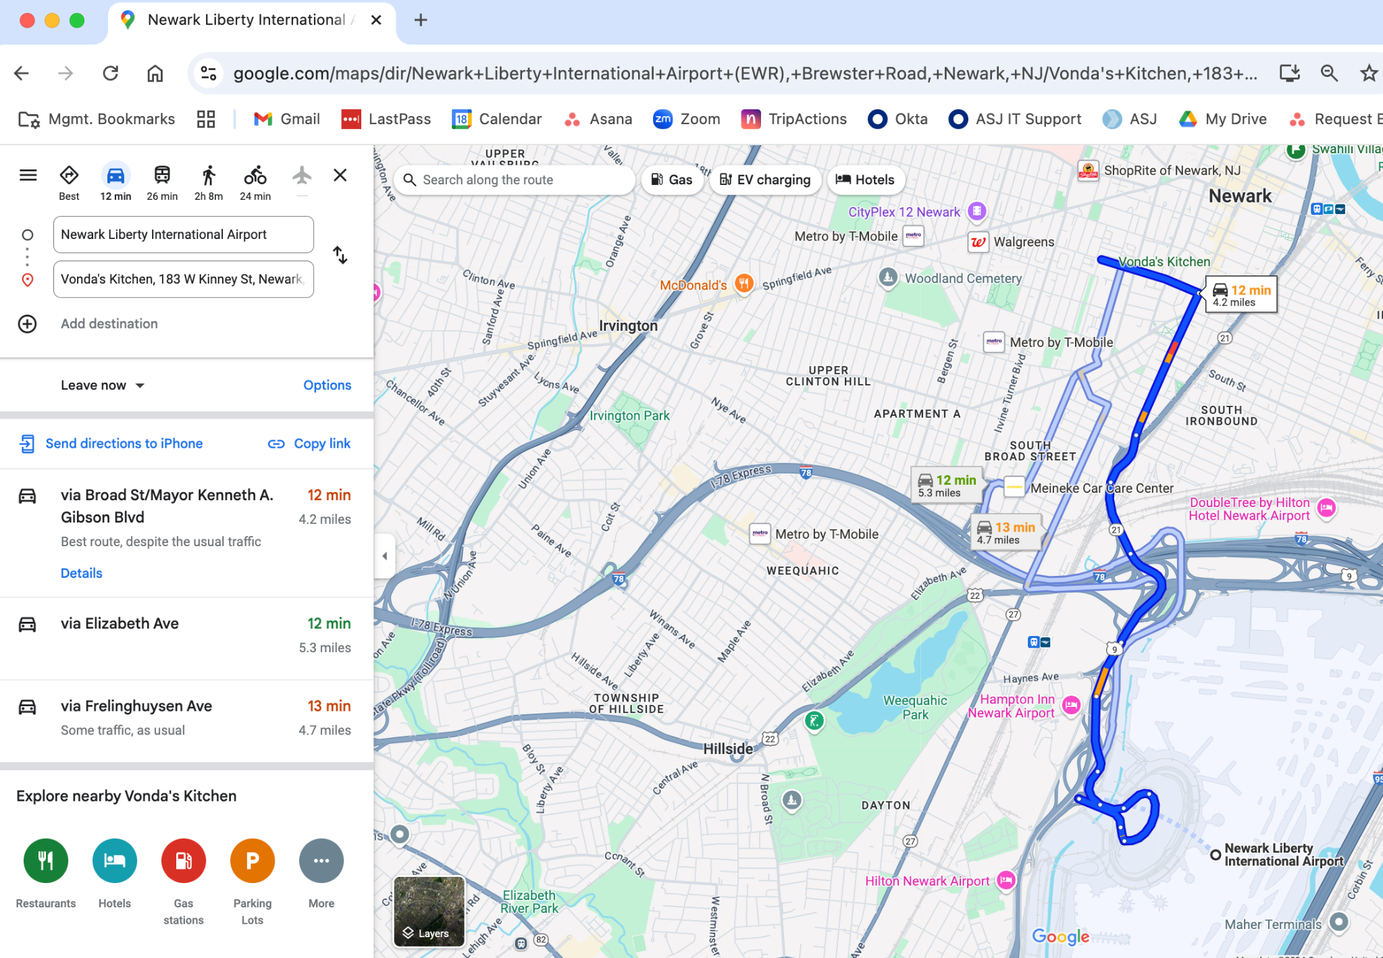

1. Click on “Add Destination” button in the left hand menu to add your favorite lunch place
2. Click on the “Add Destination” button again in the left hand menu and add your favorite dinner place
3. Write down your final route’s DISTANCE and DRIVING TIME and be prepared to share with the rest of the team

